Alpine-Ascents

*User Guide*

|  |  |  |
| --- | --- | --- |
| **Supervisor.** | **Sir Ebad Uddin Ahmed** | |
| **Batch.** | **2210E1** | |
| **Group.** | B | |
| **Serial No.** | **Enrollment Number** | **Student Name** |
| 1. | 1425610 | Ubaid Zada |
| 2. | 1425304 | Fazal Subhan |
| 3. | 1423498 | Abrar Shah |
| 4. | 1407243 | Muhammad Yasir |



1. **Home** (*index (1).html*)

***Figure 1: Home page to Alpine-Ascents***

 Our Slogan has given to the peoples toward our website. OUR HOME PAGE WELCOME OUR CUSTUMERS WITH BEAUTIFUL QOUTE.

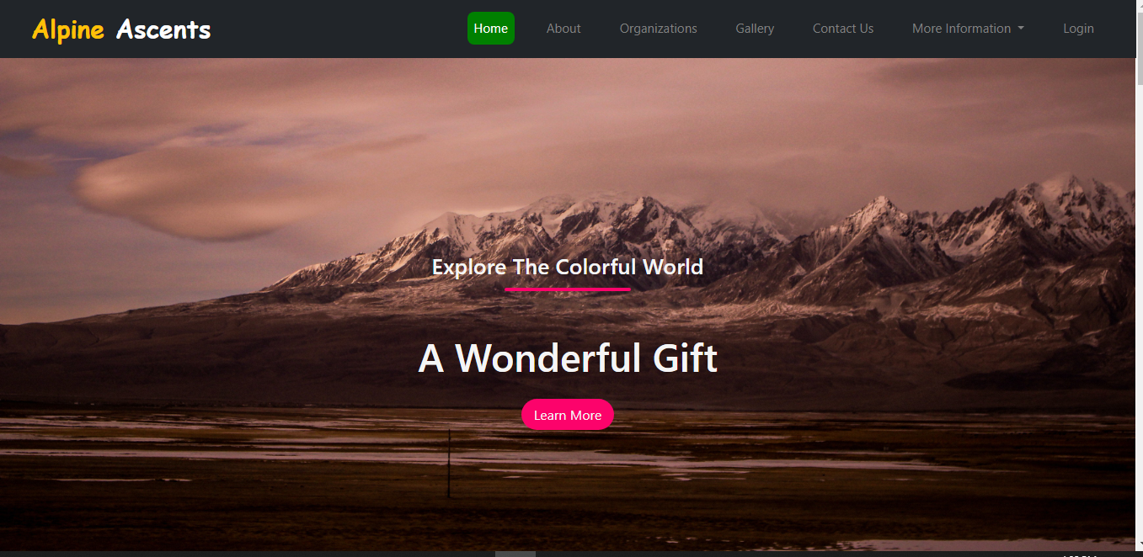

1. **Navbar (index.html)**



***Figure 2: Navbar***

We have given six essentials and one dropdown. By clicking any of the essential’s and redirect to the linked page. (Index.html)

1. **About (about .html)**

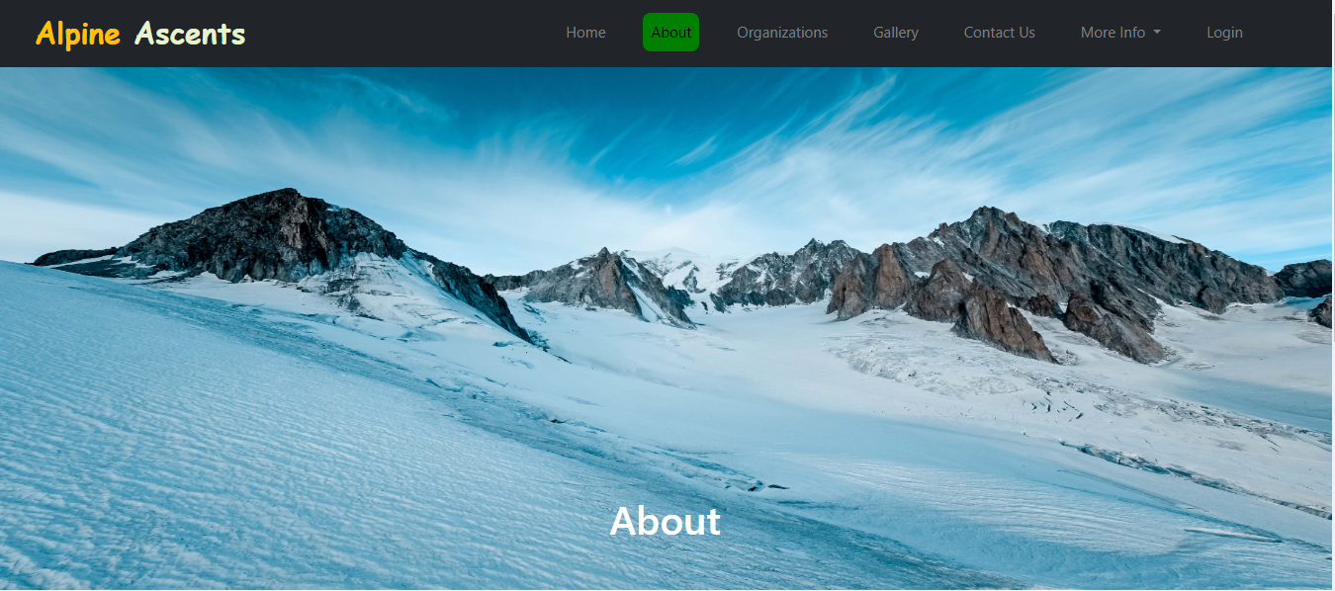

***Figure 3: About***

**



* It give the description of our project alpine ascents which is all related to mountains.
* It is a description of my group members

**4.ORGANIZATION (organization .html)**

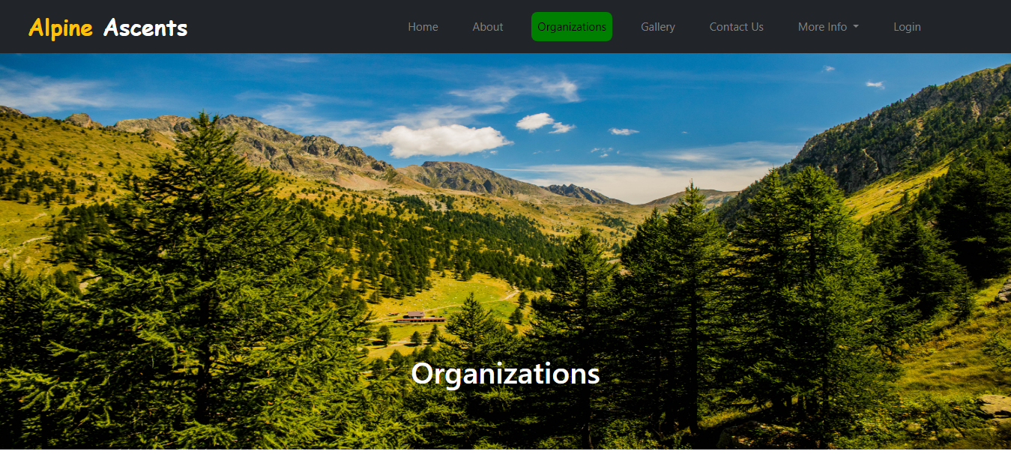

***Figure 4: Organization***

*We have mentioned about the organization of broke warren and AI Gore and full circle Everest etc.And We had discussed about the main topics of mountaining.*

***5.GALLERY (gallery .html)***



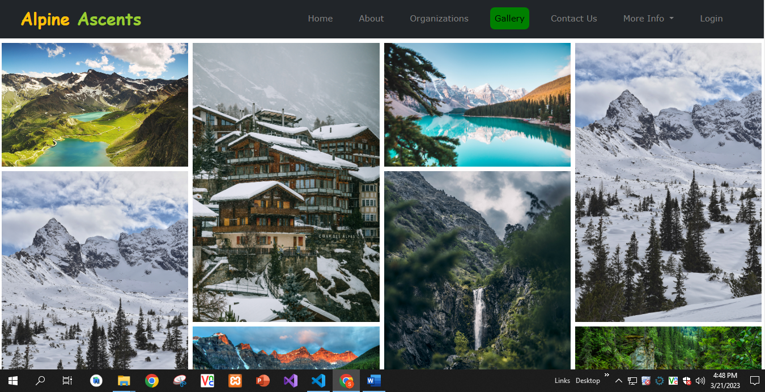***Figure 5:***

***New arrivals***

*.*

***“Gallery of mountains”***

*We have given some unique kind of images of mountains*

***6.Contact us (contact .ht******ml) :***

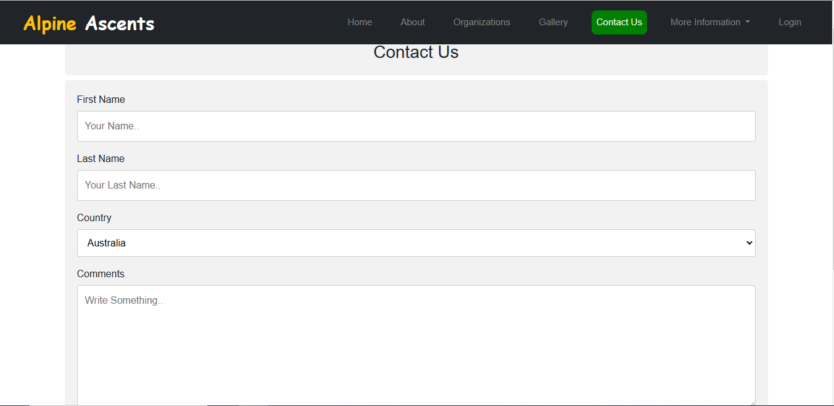

***7.History(history .html):***

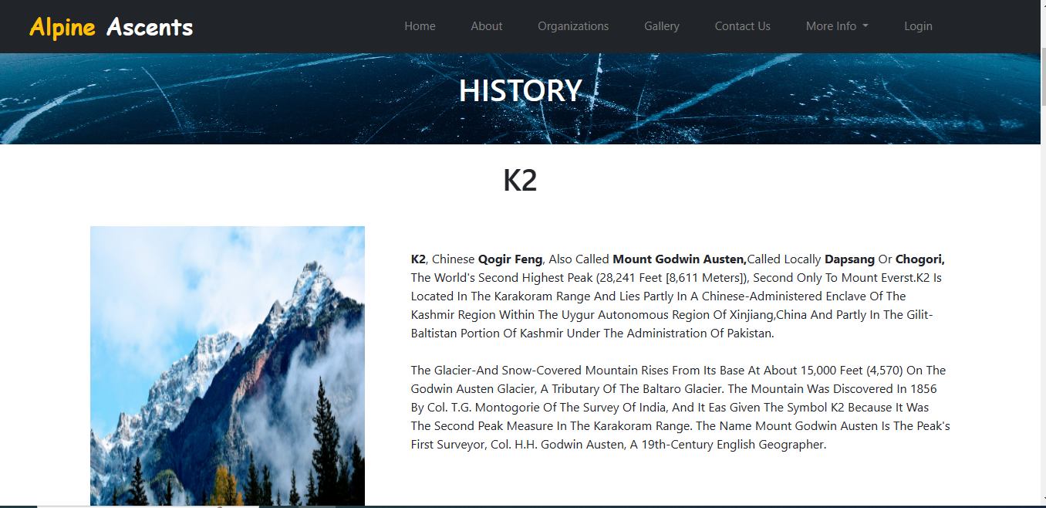

***Figure 7: History.section***

*Our history section* is designed by Ubaid zada.

***8. login(login. Html):***

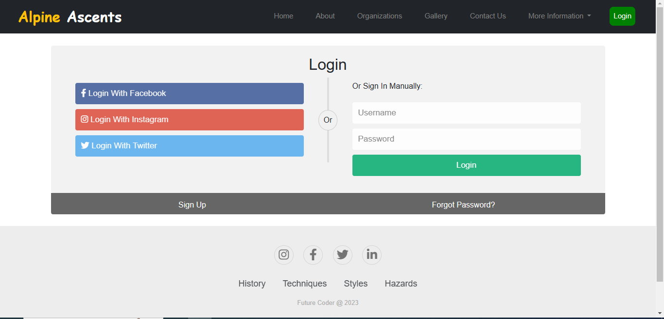

*On clicking login. Login form page open on blank page there customer show two buttons create account button and sing up button with these two options they can create their account or sing in if they have already an account****.***

***9.footer (index .html):***



***Figure 14: Footer***

We have given some hover effects in footer to make our website more relaxing.

